A

PROJECT REPORT

ON

**EMOJIFY**

**By**

VIDIT SHAH (CE-03) (19CEUON075)

CHAVDA BHAVIN (CE-23) (19UOG024)

**B.Tech CE Semester-VI**

**Subject: SYSTEM DESIGN PRACTICE**

**Guided by:**

Prof. Shaifali P. Malukani (Assistant Professor)

Dept. of Computer Engg.





**Faculty of Technology Department of Computer Engineering**

**Dharmsinh Desai University**

**CERTIFICATE**

This is to certify that the practical / term work carried out in the subject of **SYSTEM DESIGN PRACTICE** and recorded in this journal is the bonafide work of

VIDIT SHAH (CE-03) (19CEUON075)

CHAVDA BHAVIN (CE-23) (19UOG024)

of B.Tech Semester **VI** in the branch of **Computer Engineering** during the academic year **2021-2022**.

Project Guide: Head of The Department

Prof. Shaifali P. Malukani Dr. C.K Bhensdadia

Assistant Professor Prof. & Head

Dept. of Computer Engg., Dept. of Computer Engg.,

Faculty of Technology Faculty of Technology

Dharmsinh Desai University, Nadiad Dharmsinh Desai University,Nadiad

INDEX

1. Abstract 1

2. Introduction 2

2.1 Brief Introduction 2

2.2 Tools/Technologies Used 3

3. Software Requirement Specifications 4

3.1 Product Scope: 4

3.2 System Functional Requirements 4

3.3 Other Non-functional Requirements: 6

4. Design 7

4.1 Use Case Diagram: 7

4.2 Activity Diagram: 8

4.3 Class Diagram: 10

4.4 DFD Model: 11

4.5 Sequence Diagram: 13

5. Implementation 14

5.1 Login Module: 14

5.2 Room Module: 14

5.3 Chat Module: 14

5.4 Emoji Module: 14

5.5 Function Prototypes: 15

5.6 Model Training- 21

6. Testing 24

7. Screenshots 25

8. Conclusion 29

9. Limitation and Future Enhancements 30

10. Reference / Bibliography 30

1. Abstract

Chatting is now-a-days very useful to express our ideas as well as receive others ideas on any topic. Chats reflect the recent trends of the society. Sometimes, it is possible to meet eminent people in chatting and have their advice. So, we bring chat application for our users with great feature such as emojify which recognizes users face expression and prints emoji. The combination of visual and textual content in the same message builds up a modern way of communication.

1. Introduction
   1. Brief Introduction

In the fast-moving world, most of us are connected with chatting. User can create group and connect with multiple people at same time. Chat and interact with other members of the group. Admin can edit/remove member of the group. As Emojis have become a new language that can more effectively express an idea or emotion we bring seven different emotions recognize of user and giving you the best and most accurate result in form of emoji.

Emojify- We are building a convolution neural network to recognize facial emotions. We will be training our model on the FER2013 dataset. Then we’ll map those emotions with the corresponding emojis. Fer2013 contains approximately 30,000 facial RGB images of different expressions with size restricted to 48×48, and the main labels of it can be divided into 7 types: 0=Angry, 1=Disgust, 2=Fear, 3=Happy, 4=Sad, 5=Surprise, 6=Neutral.

After training 4 models, we found a model with better accuracy as we added more images to data of ourselves and tested it with the data.

* 1. Tools/Technologies Used

**Technologies:**

* Python
* MongoDB
* Flask
* HTML, CSS, JS
* JQuery
* Socket io
* Neural Network

**Tools:**

* Visual Studio Code
* MongoDB Atlas
* Github

**Platform:**

* Local development server

**Libraries:**

* Numpy
* Pandas
* Tensorflow
* Keras
* matplotlib

1. Software Requirement Specifications
   1. Product Scope:

This System is designed to connect and share their real time emotion through emojis with each other.

* 1. System Functional Requirements

**R.1 Manage User**

R.1.1 Sign up

Description: User creates account by entering details.

Input: Username, email address and password.

Output: Login page is displayed.

Processing: If username is unique then user is transferred to login page.

R.1.2 Login

Description: User logins to the system by entering valid username and password.

Input: Username and Password.

Output: Index Page is displayed having chat rooms if user successfully logs in.

Processing: Username and Password validation.

**R.2 Manage Room**

R.2.1 Create Room

Description: User can create new room and add his friends to it.

Input: Room name, Friend’s username

Output: Room is successfully created and displayed in my rooms.

R.2.2 Edit Room

Description: Admin can edit room name and add new member.

Input: Room name, Member username

Output: Room name is changed and new member is added to the room.

**R.3 Manage Message:**

R.3.1 Send Message

Description: Type your message in box and send.

Input: Message

Output: Message is sent successfully and other members can read the message.

**R.4 Manage Emotion:**

R.4.1 Recognize Facial Expression

Description: Recognize facial expression and maps it with emojis.

Input: Opens camera and take face expression

Output: Emoji is printed in chat box.

* 1. Other Non-functional Requirements:

1. Performance:

The system must be interactive and must not involve long delays. Though in case of opening the website components or loading the page the system shows the delay less than 2 seconds.

1. Safety:

The user’s data is highly personal. The system has authorization to avoid any un-authorization access to user’s private data.

1. Reliability:

As the system has personal data, its reliability is the major factor for consideration.

1. Design
   1. Use Case Diagram:

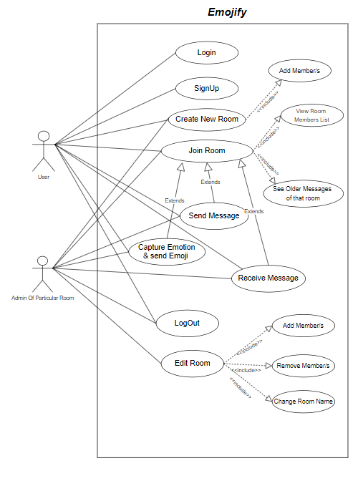

* 1. Activity Diagram:

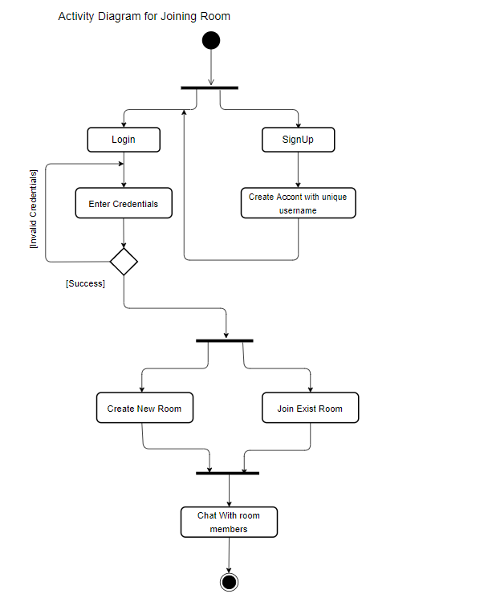

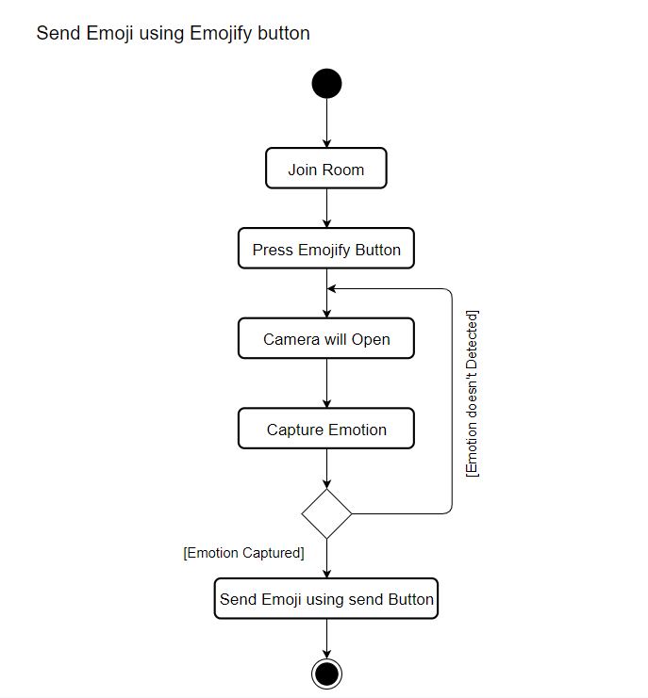

* 1. Class Diagram:

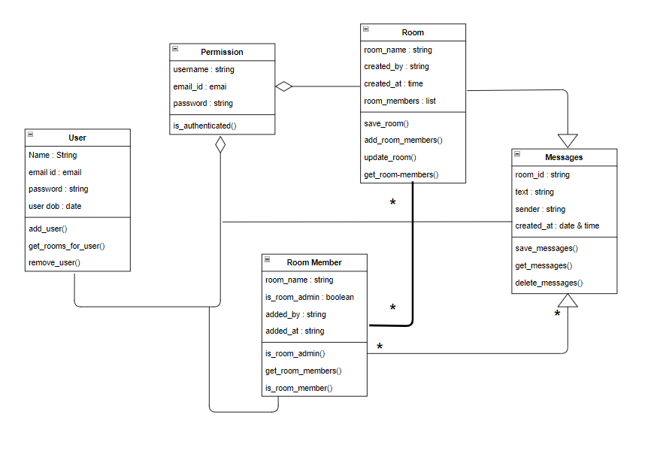

* 1. DFD Model:

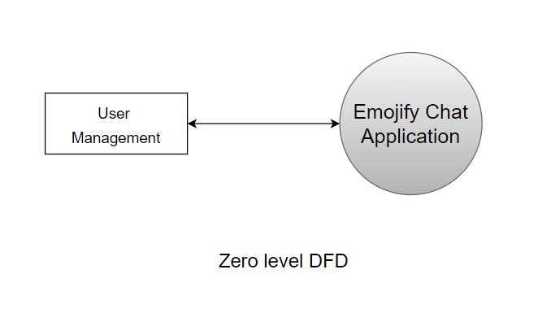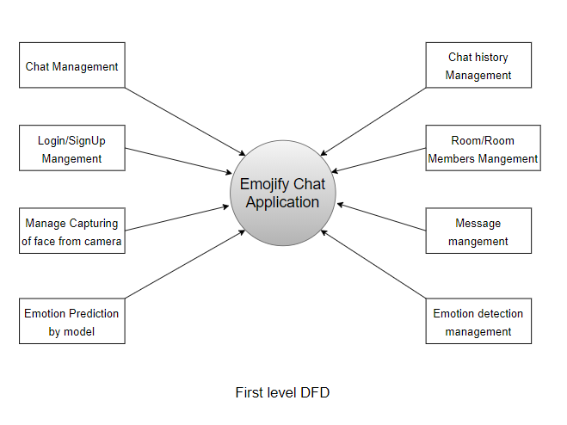

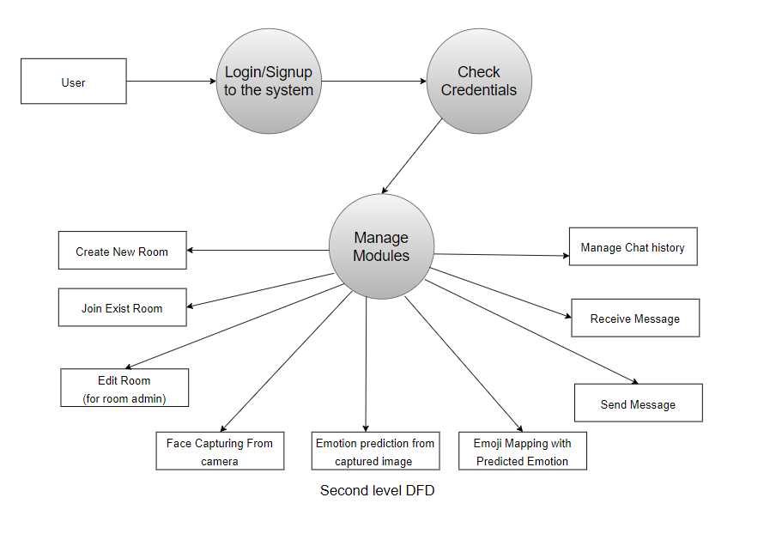

* 1. Sequence Diagram:

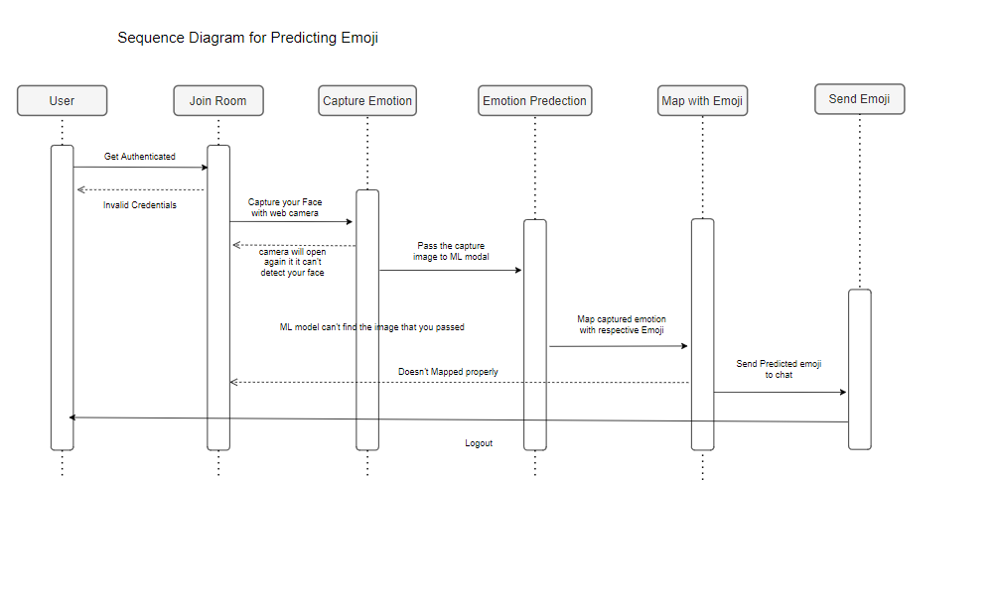

1. Implementation

The system consists of 4 basic modules namely

1. Login Module
2. Room Module
3. Chat Module
4. Emoji Module
   1. Login Module:

User will login using his/her credentials and will be redirected to Index Page.

* 1. Room Module:

User can create room and join the existing rooms. If user is admin of room, he/she can edit room participant.

* 1. Chat Module:

User can send, receive and load older messages. Also, he/she can view members in the group.

* 1. Emoji Module:

Capture users face expression and gives an emoji in the text box.

* 1. Function Prototypes:

Login Page:

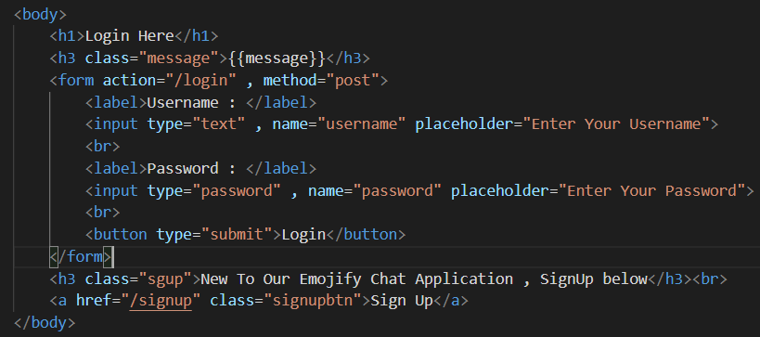

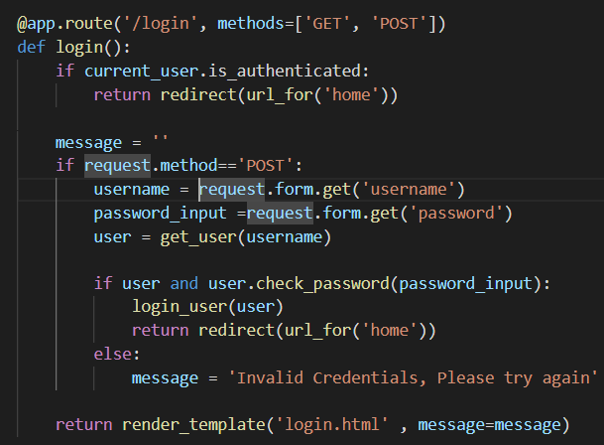

Room Module:

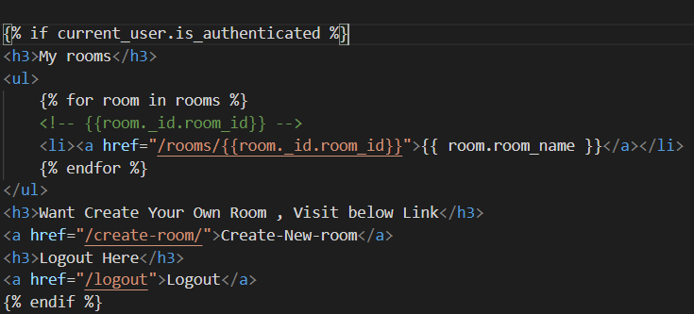

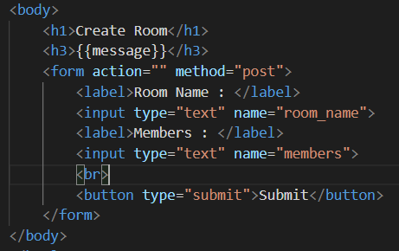

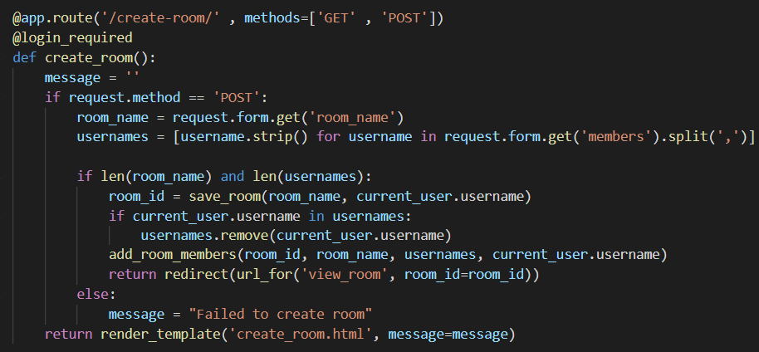

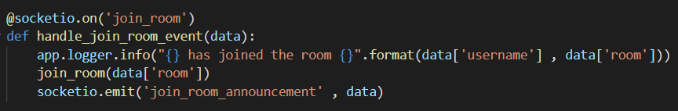

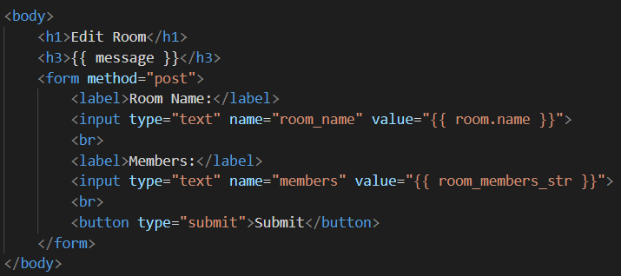

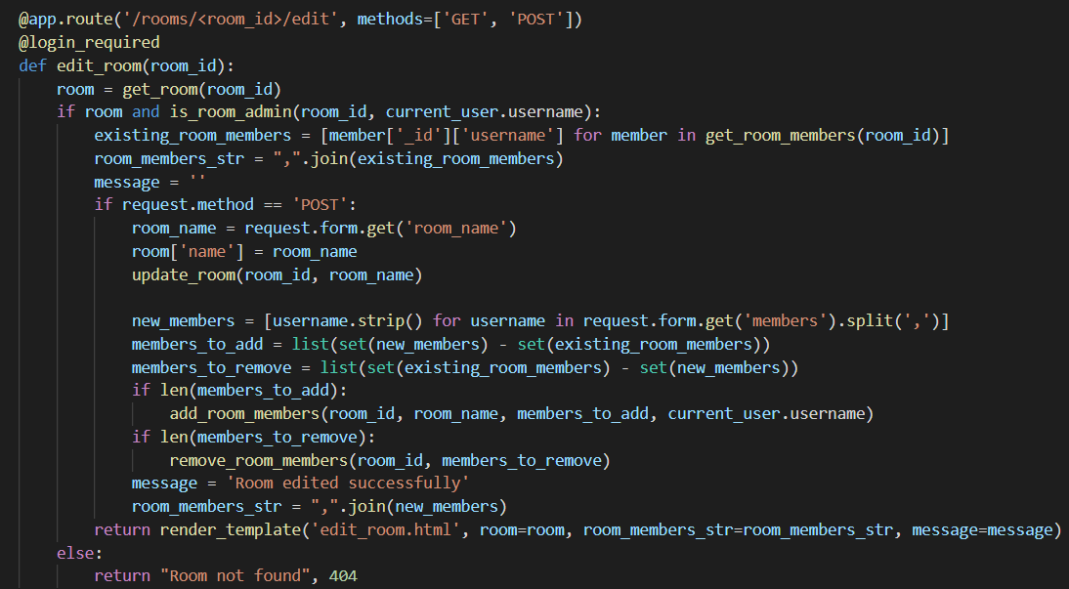

Chat Module:

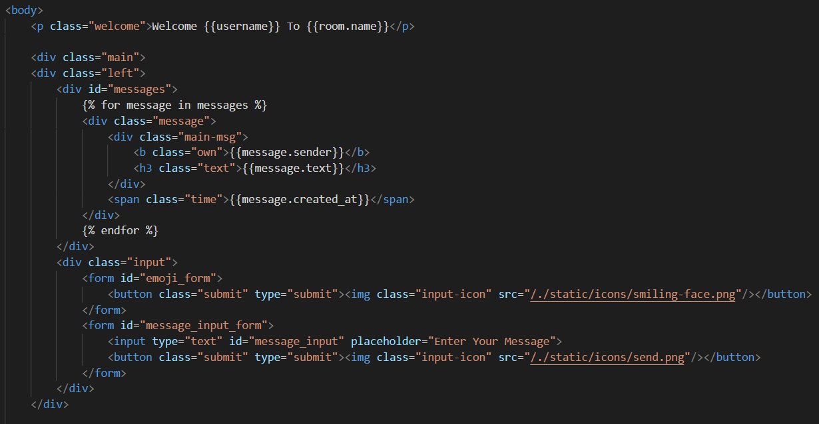

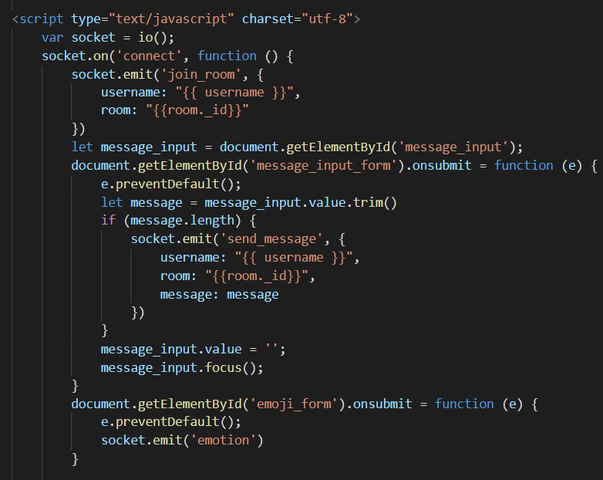

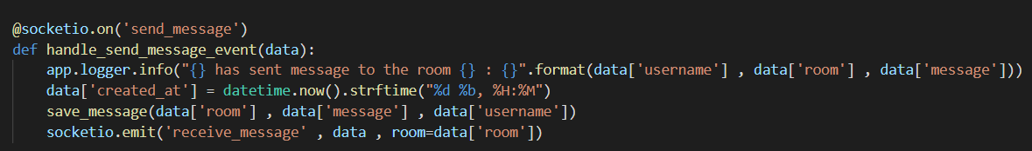

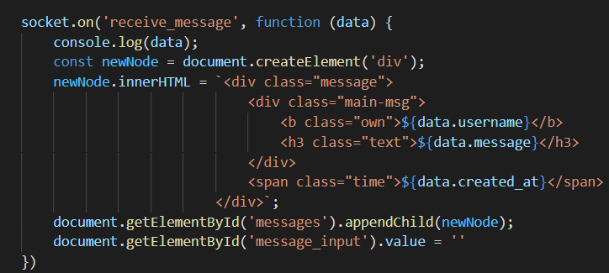

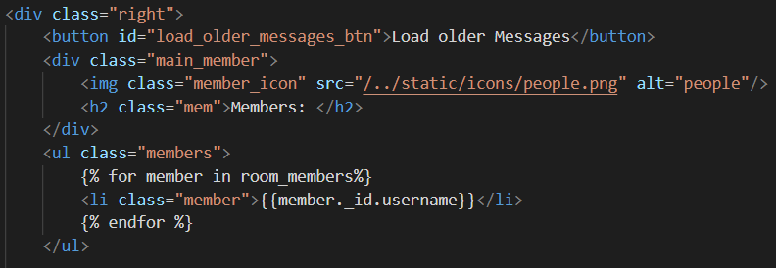

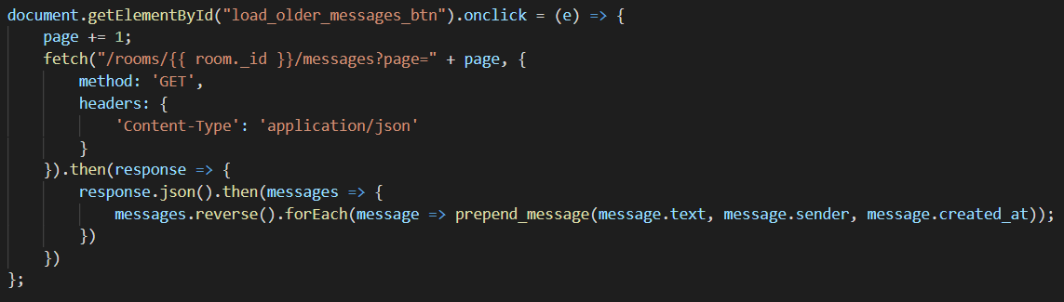

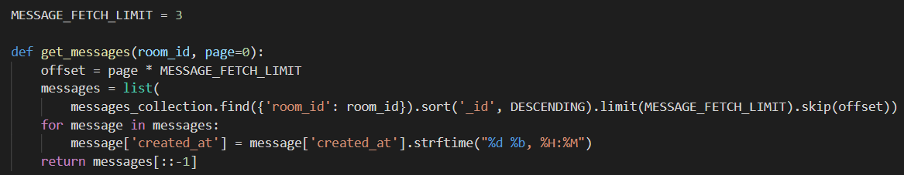

Emoji Module:

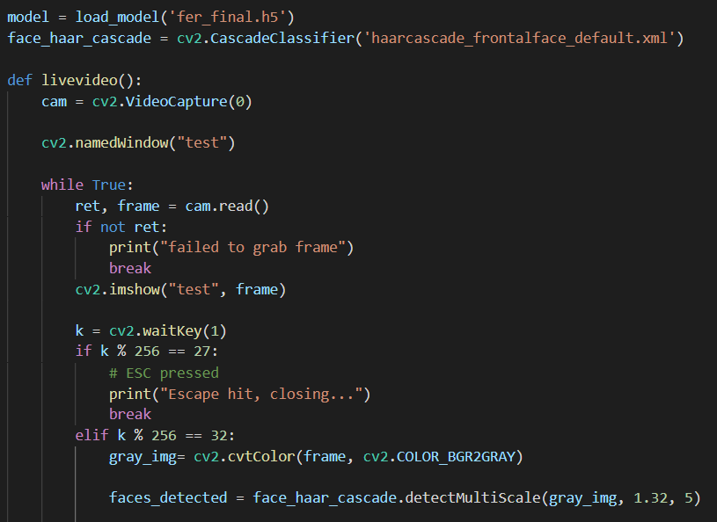

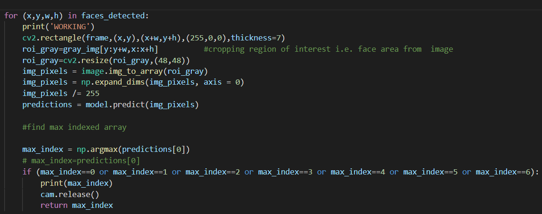

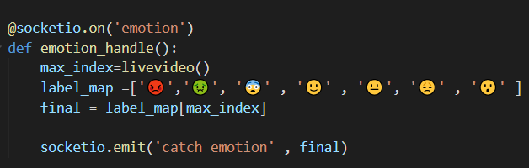

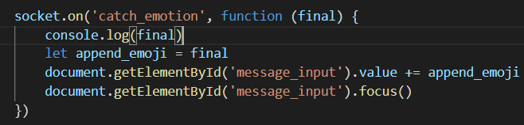

* 1. Model Training-

1. Importing Libraries:

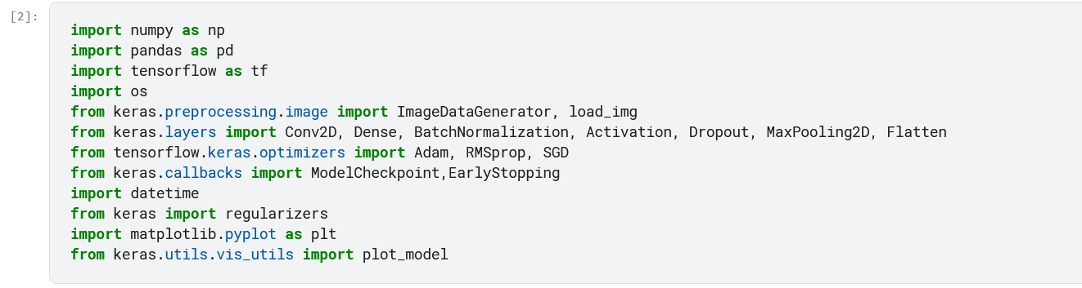

1. Loading data:

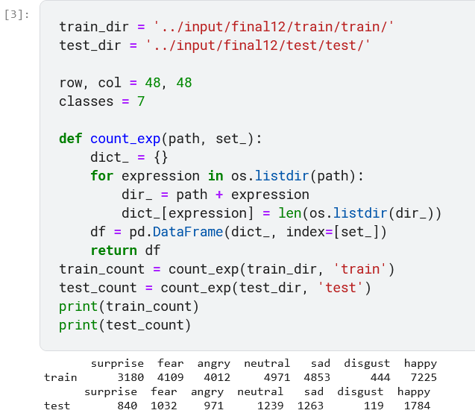

1. Data Augmentation:

rescale = to scale down the pizel values in our image between 0 and 1.

horizontal_flip = flips the image horizontally.

validation_split = reserves some images to be used for validation purpose.

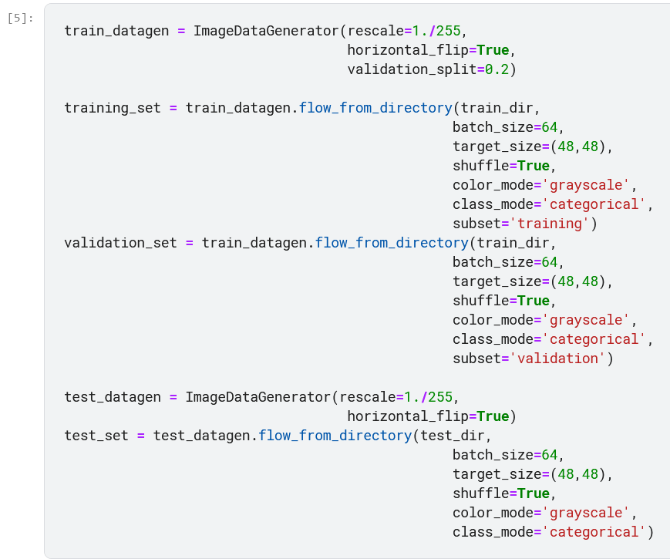

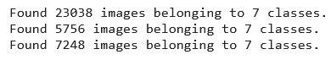

1. Modelling

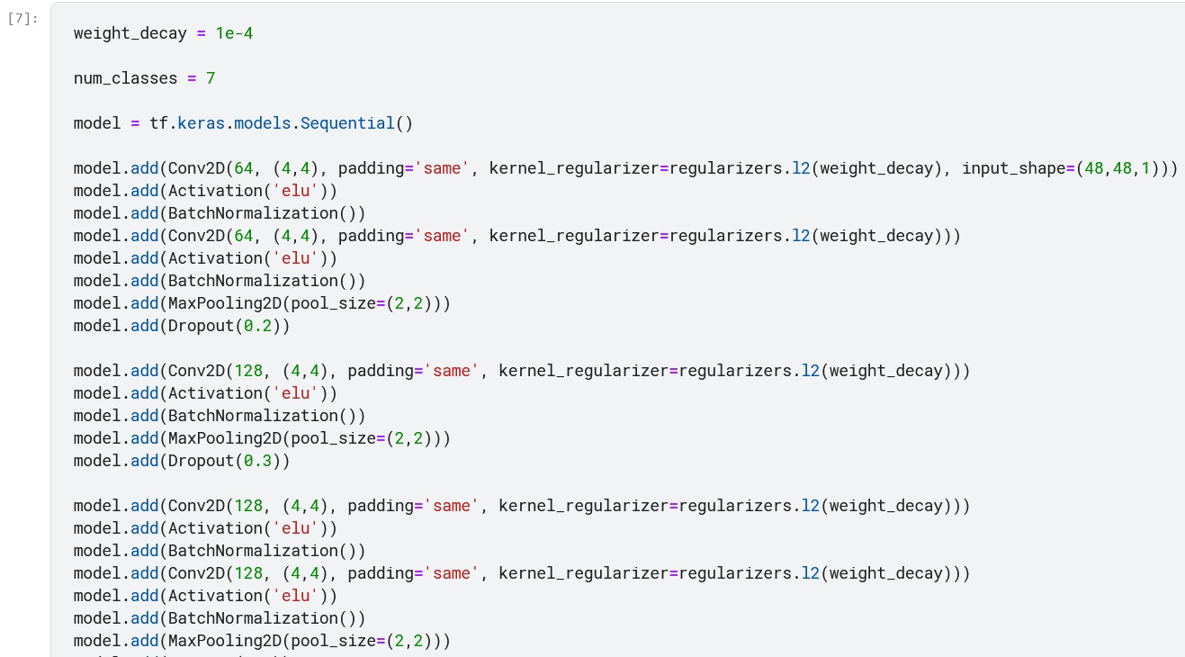

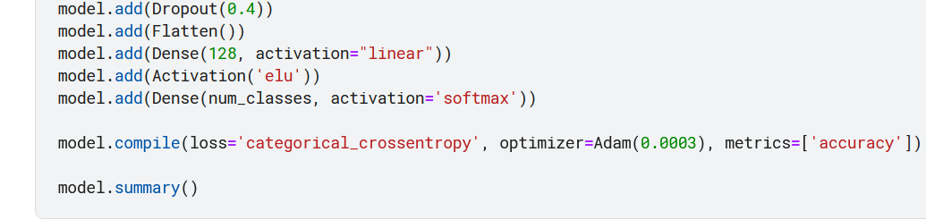

1. Training the model

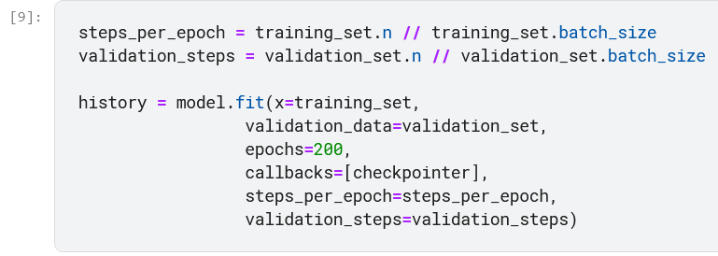

1. Saving the model

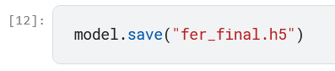

1. Testing

Training Loss: It indicates how well the model is fitting the training data.

Validation Loss: It indicates how well the model fits new data.

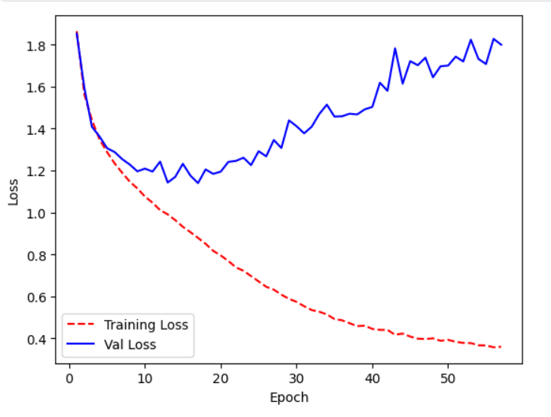

Training Accuracy: It indicates how the model is able to classify the two images during training on the training dataset.

Validation Accuracy: It indicates how the model is able to classify the images with the validation dataset.

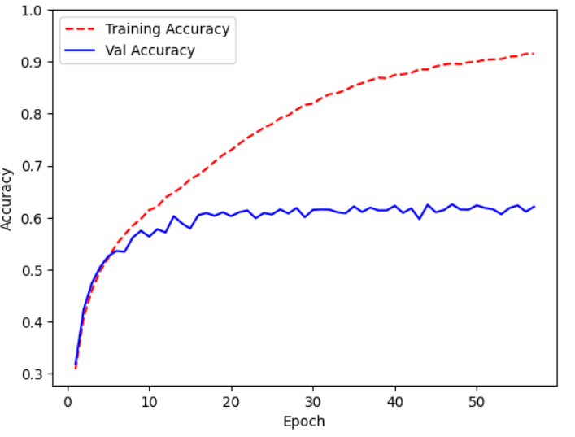

Test Accuracy:



1. Screenshots

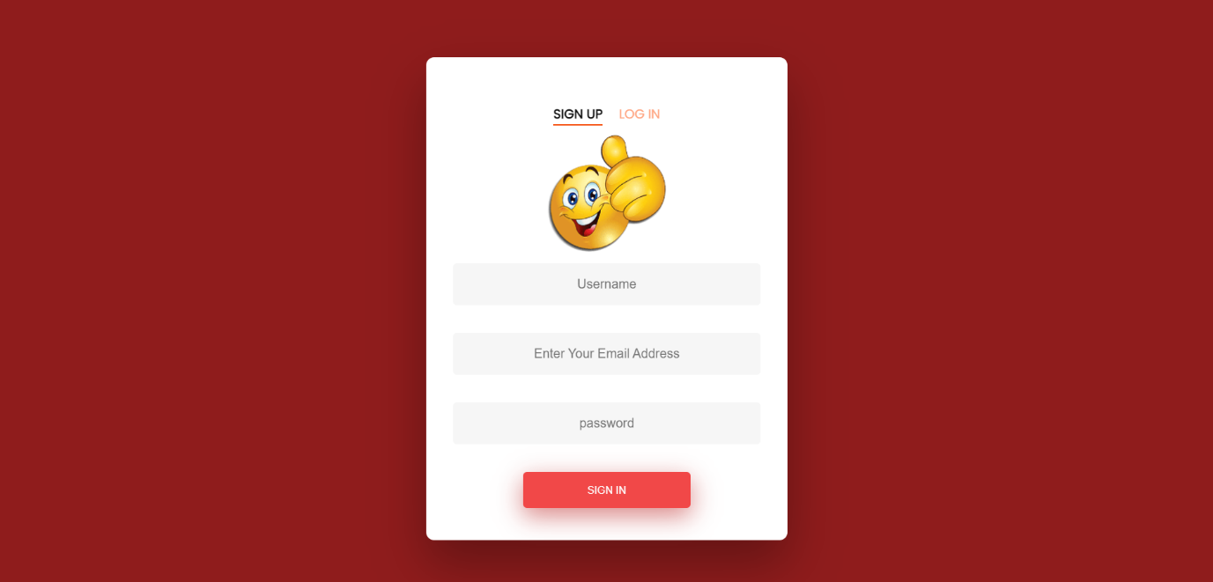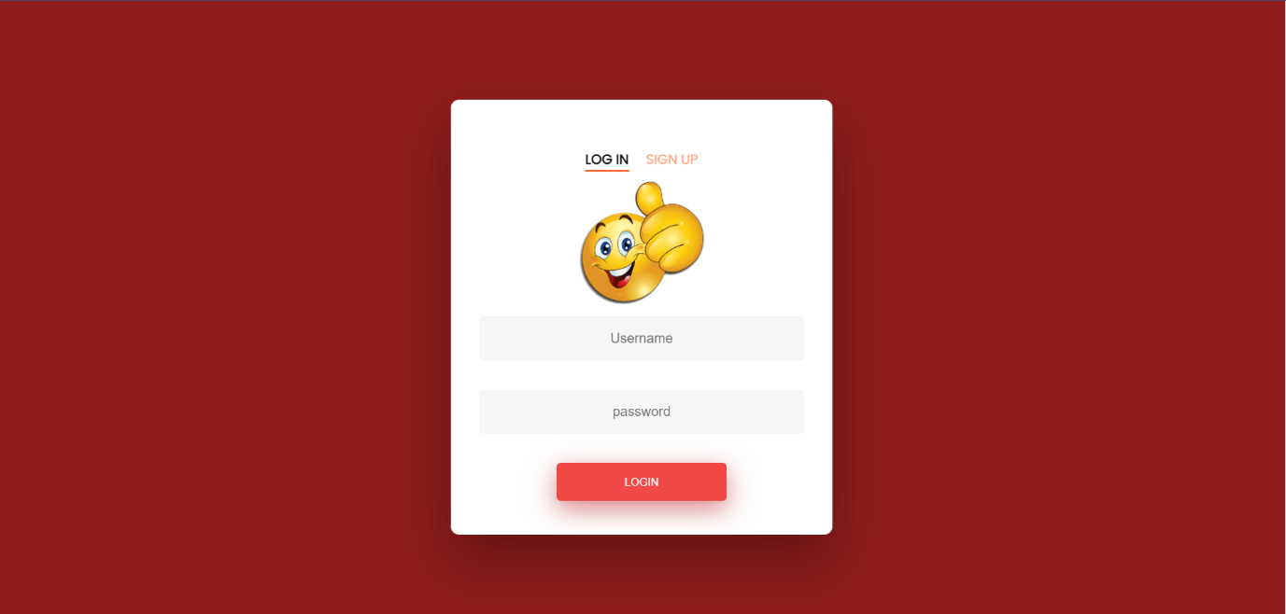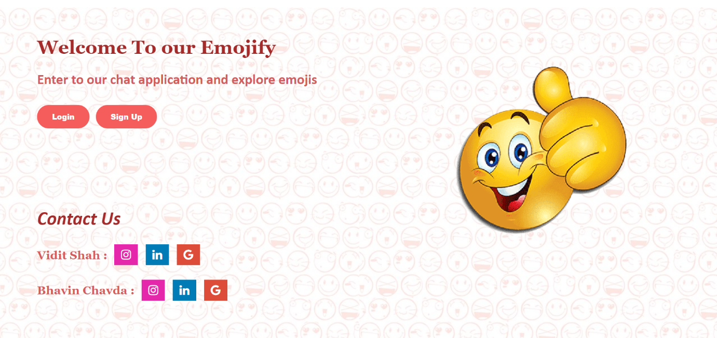

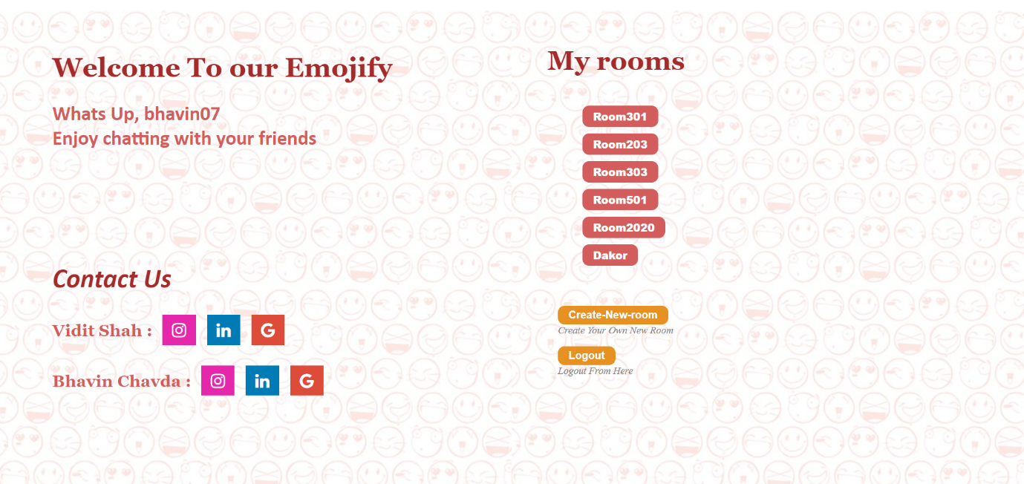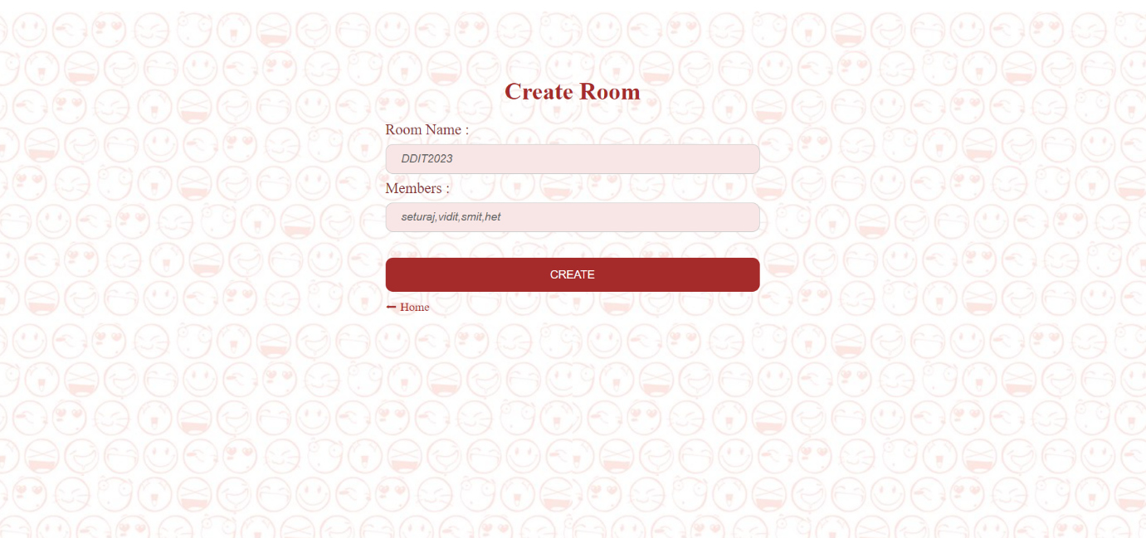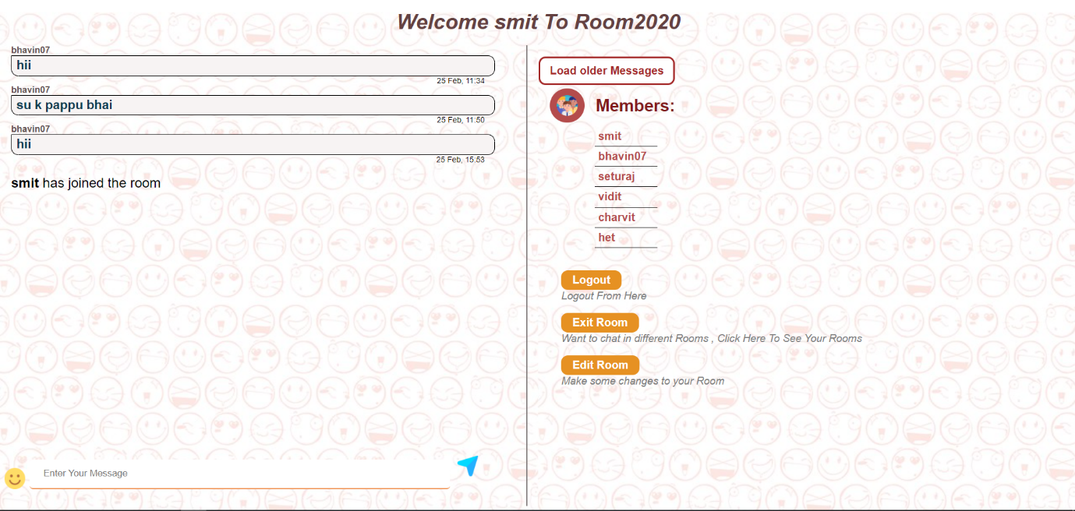

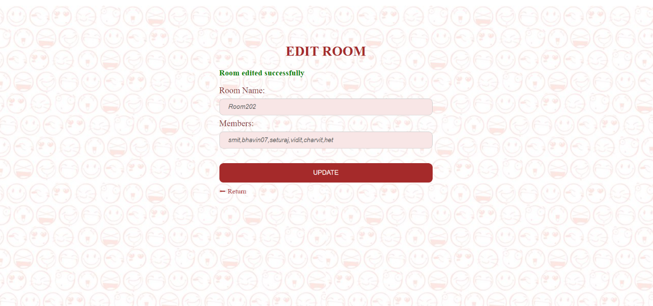

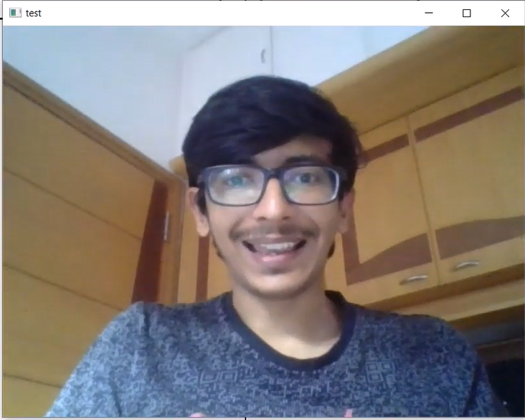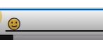

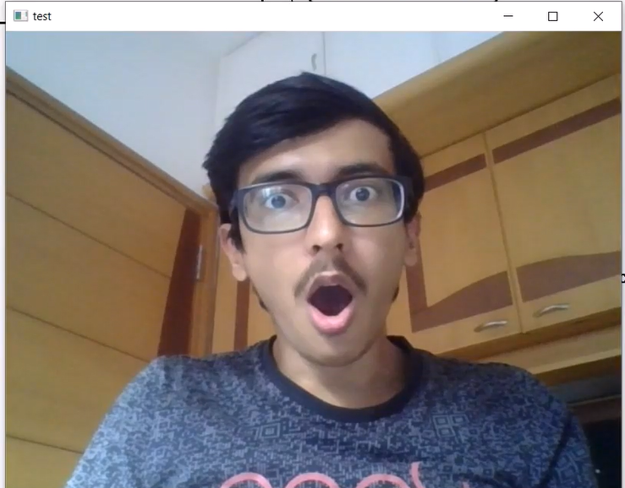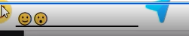

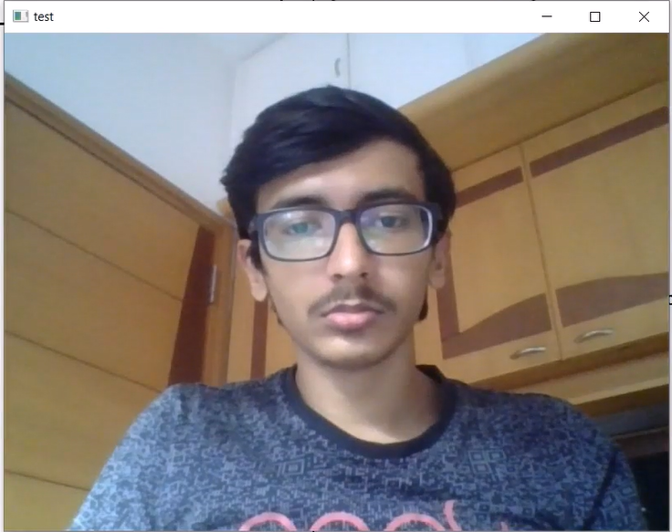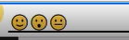

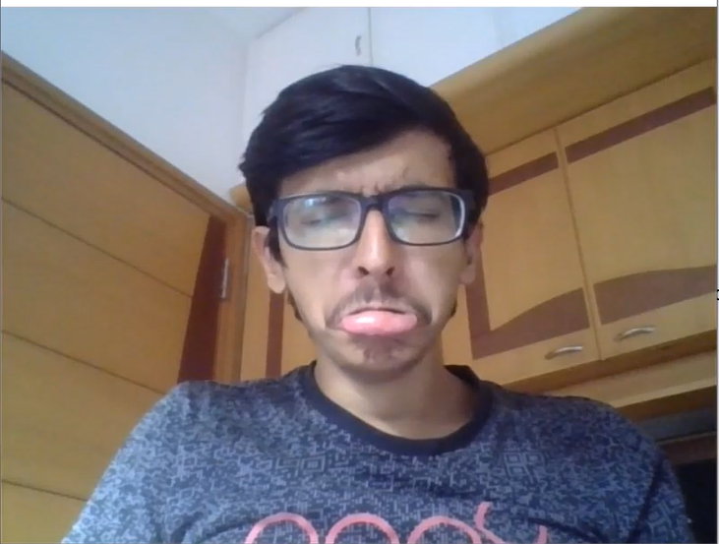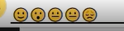

You can watch our emoji testing video-

<https://drive.google.com/drive/folders/1H_m0Qz08Dhs6yNzuRKTH3ikbcWJU51Ky?usp=sharing>

1. Conclusion

The functionalities are implemented in the system after understanding all the system modules according to the requirements. We have built our own model by taking some data from the internet and other by adding our own facial expression to the model. Functionalities that are successfully implemented in the system are:

* Login/Sign up
* User validation
* Create Room
* Join Room
* Send/Receive Message
* Load older Messages
* Recognize facial expression and send emoji
* Edit Room

After the implementation and coding of system, comprehensive testing was performed on the system to determine the errors and possible flaws in the system.

1. Limitation and Future Enhancements

The Disgust expression has the minimal number of images – 600 so there is a high possibility that it has the least mapped expression. We have added our own face expression to the model to make it more accurate. Currently, the project runs completely fine if all inputs / selections are given with proper criteria.

In future, we will try to add more emotion to the model and make it more accurate. Add spam detection to the sent message so that the receiver can get notified that this contact is a spam.

1. Reference / Bibliography

Following links and websites were referred during the development of this project:

* Training Dataset, <https://www.kaggle.com/datasets/msambare/fer2013>. Accessed on January 2022.
* Creating Chat Application, <https://www.youtube.com/watch?v=uJC8A_7VZOA&list=PLyb_C2HpOQSBUEDI7tx_W4hAz699B6D7p&index=1>. Accessed on February 2022.
* For Client server, <https://flask-socketio.readthedocs.io/en/latest/>. Accessed on February 2022.
* To model group layers into object, <https://www.tensorflow.org/api_docs/python/tf/keras/Model>. Accessed on January 2022.